**Lab Exercise 7– Creating Multiple IAM Users in**

**Terraform**

**Steps:**

**1. Create a Terraform Directory:**

# mkdir terraform-iam-users cd terraform-iam-users

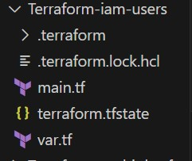

• Create Terraform Configuration Files: • Create a file named main.tf:

**# main.tf**

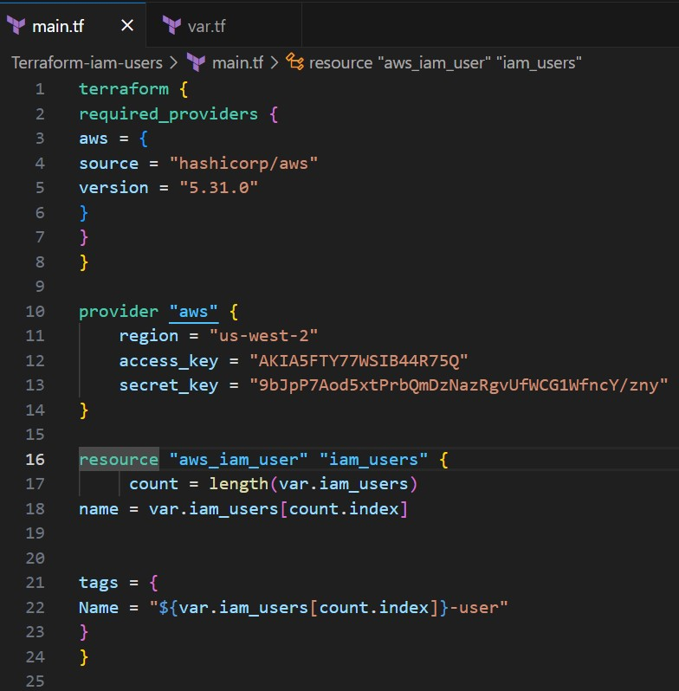

**#var.tf**

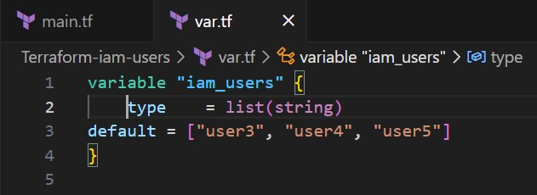

**2. Initialize and Apply:**

Run the following Terraform commands to initialize and apply the configuration:

# terraform init terraform apply

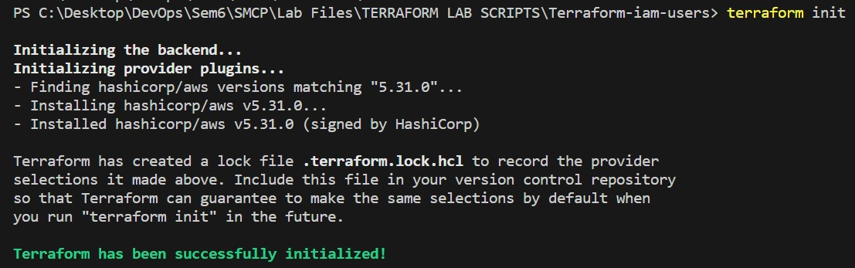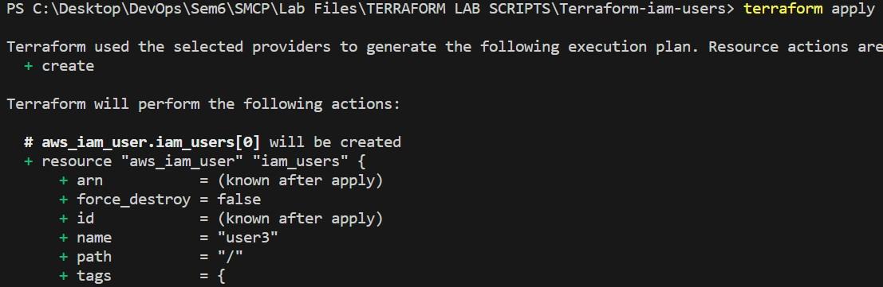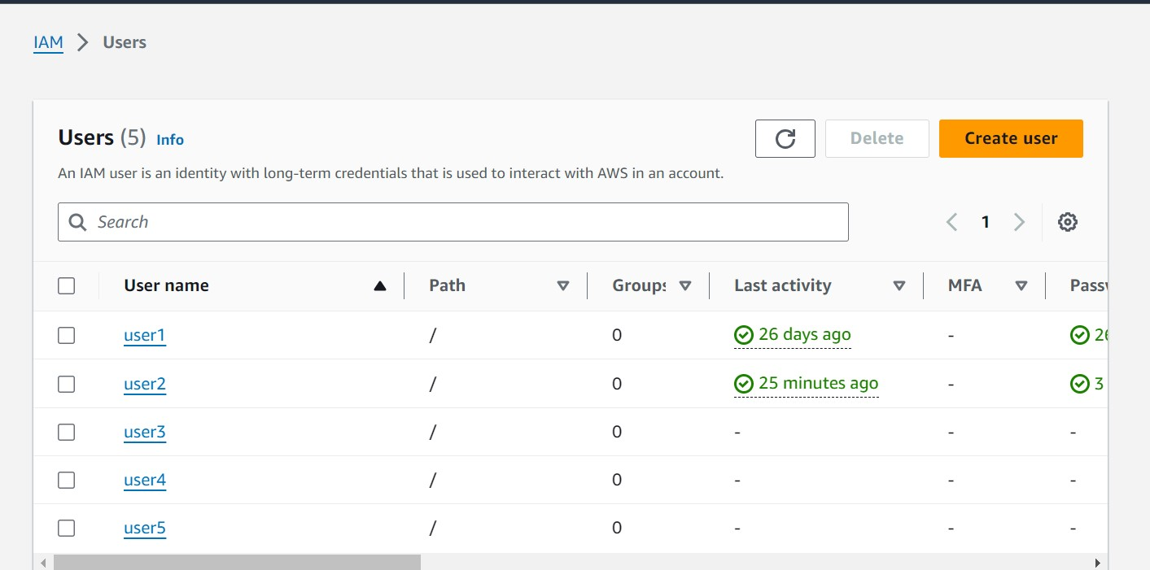

1. **Verify Users in AWS Console:**



1. **Clean Up:**

• After testing, you can clean up the IAM users:

# terraform destroy

